Section 3: Time Series, Aggregation, and Filters

Data Extract vs. Live Connection to the Dataset

Your data is constantly being updated and you wanted to work with a static file when building your visuals (you will later return to the live connection when the visual is ready)

Working with Time Series

Months (in blue): Dimension - ignores higher periods such as year, treated as a category like Gender

Months (in green): Measures - create a proper timeline

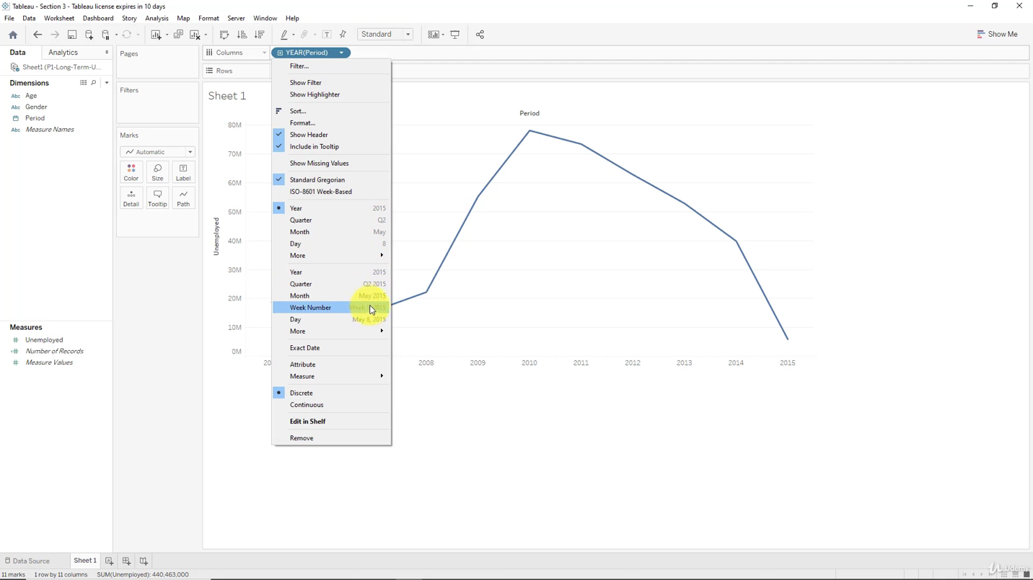

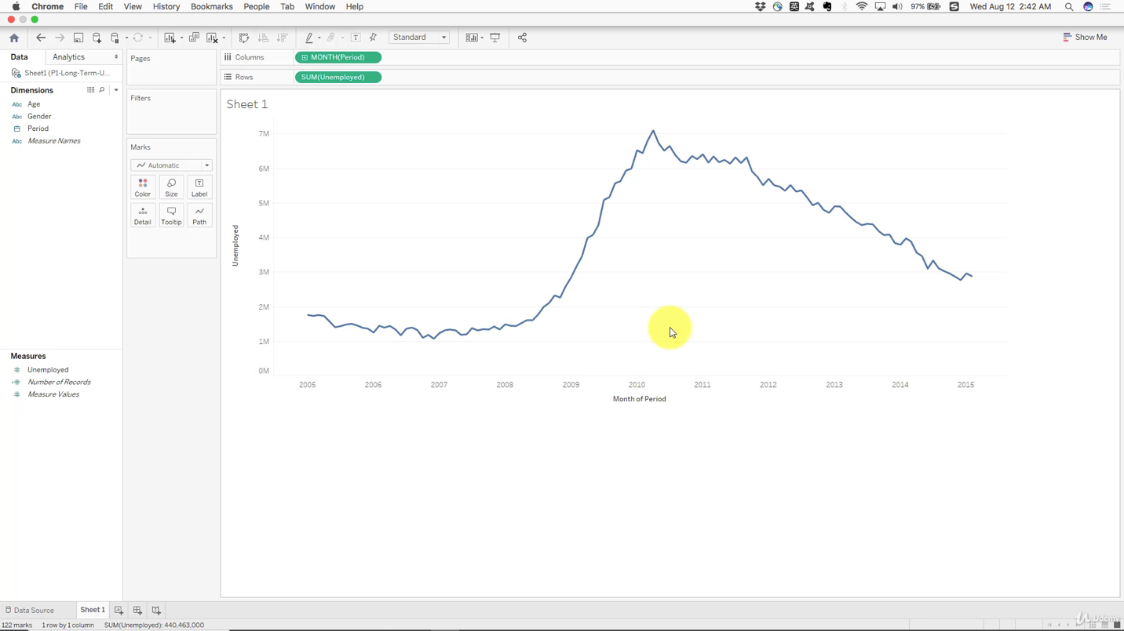

Aggregation, Granularity, and Level of Detail

Values are always aggregated at the level of granularity of the worksheet

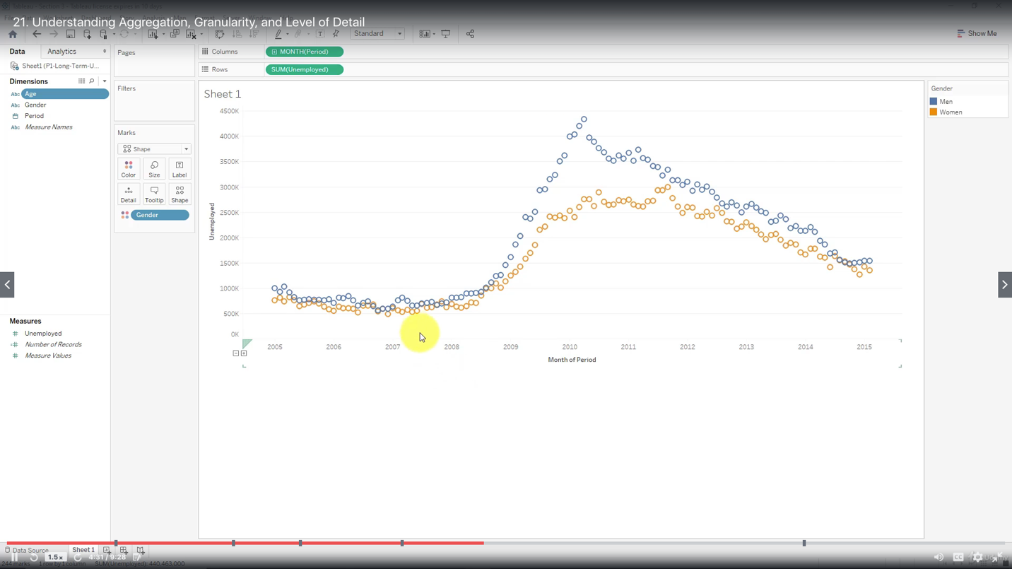

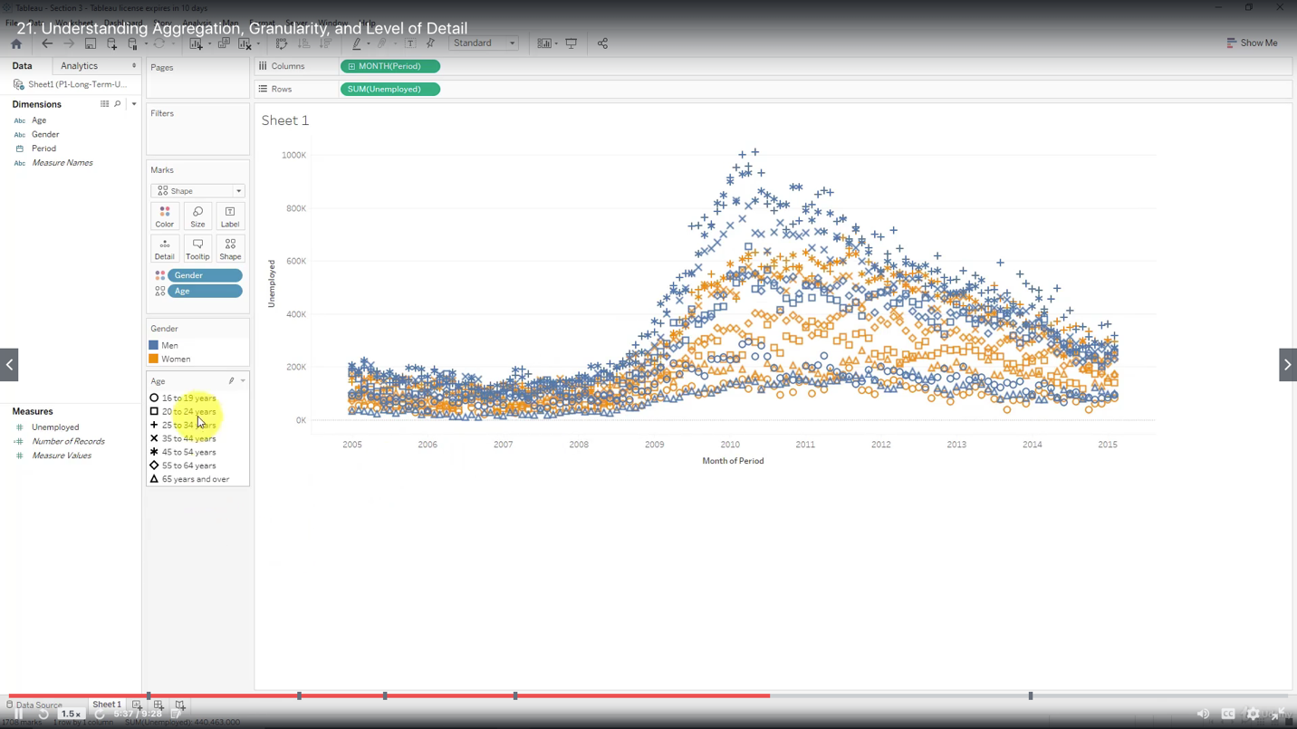

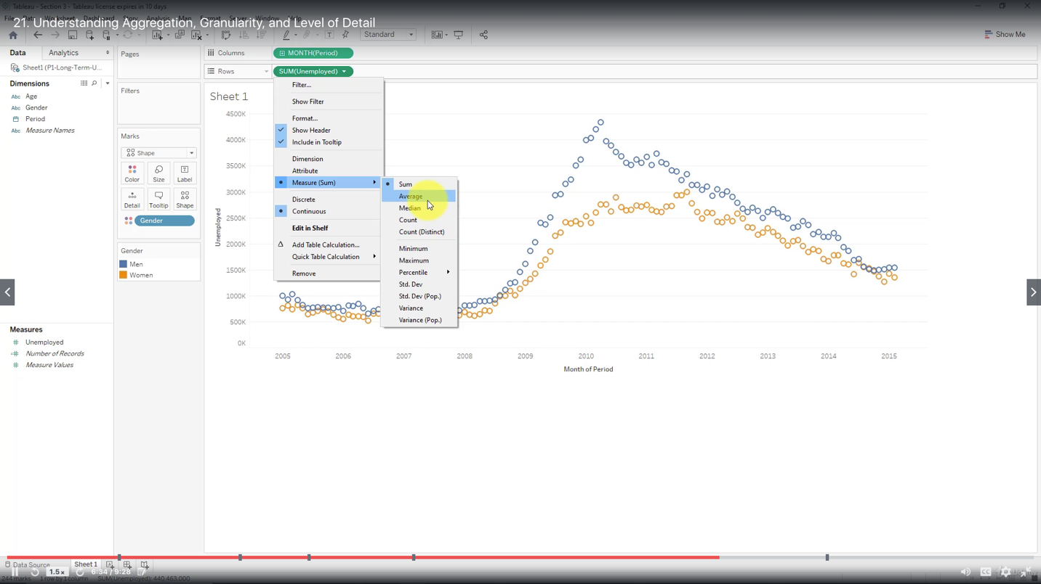

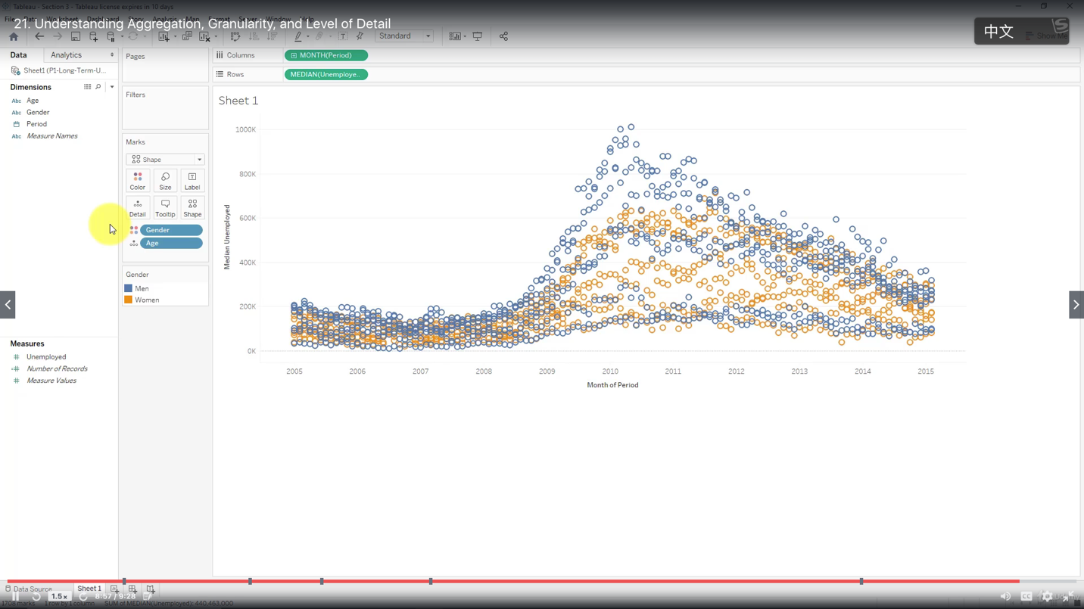

Highlighting

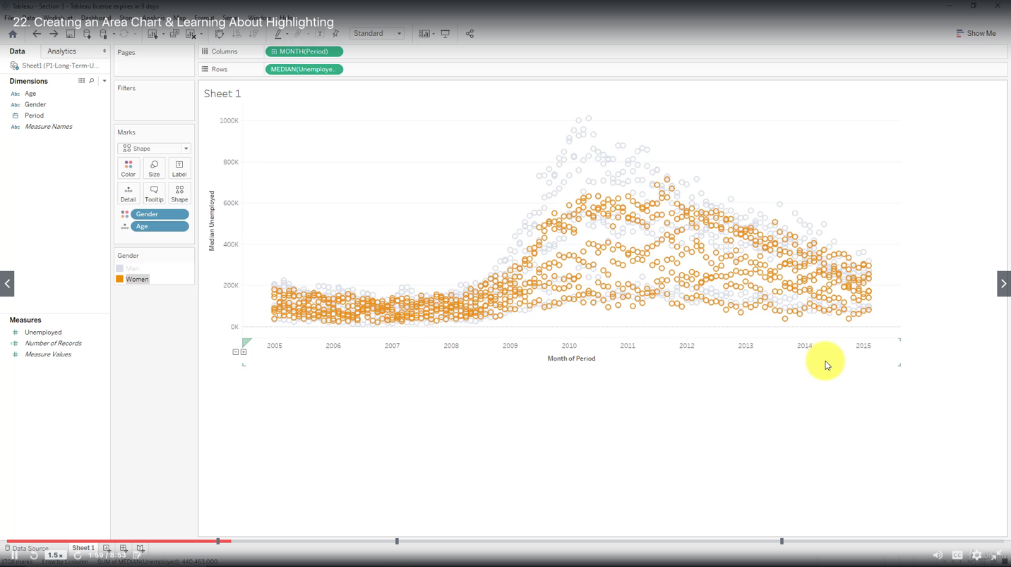

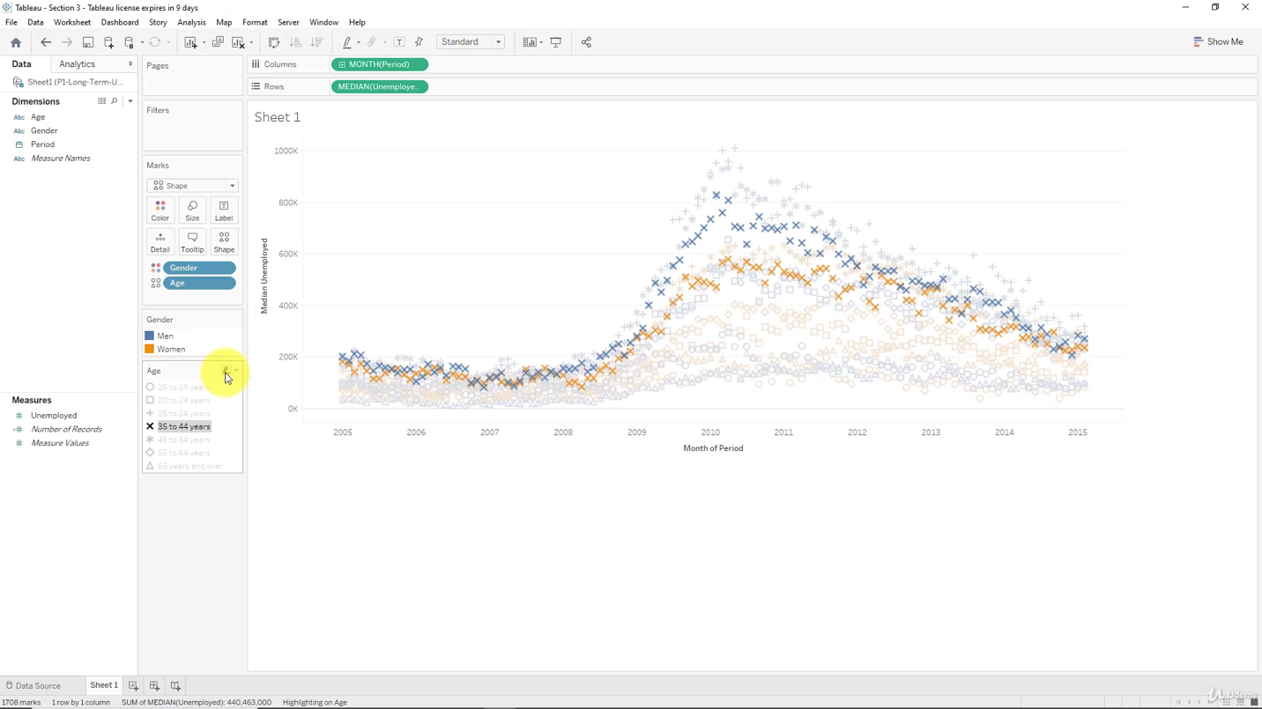

Area Chart

An area chart stacks up values of different categories on top of each other, whereas a line chart visualizes them separately

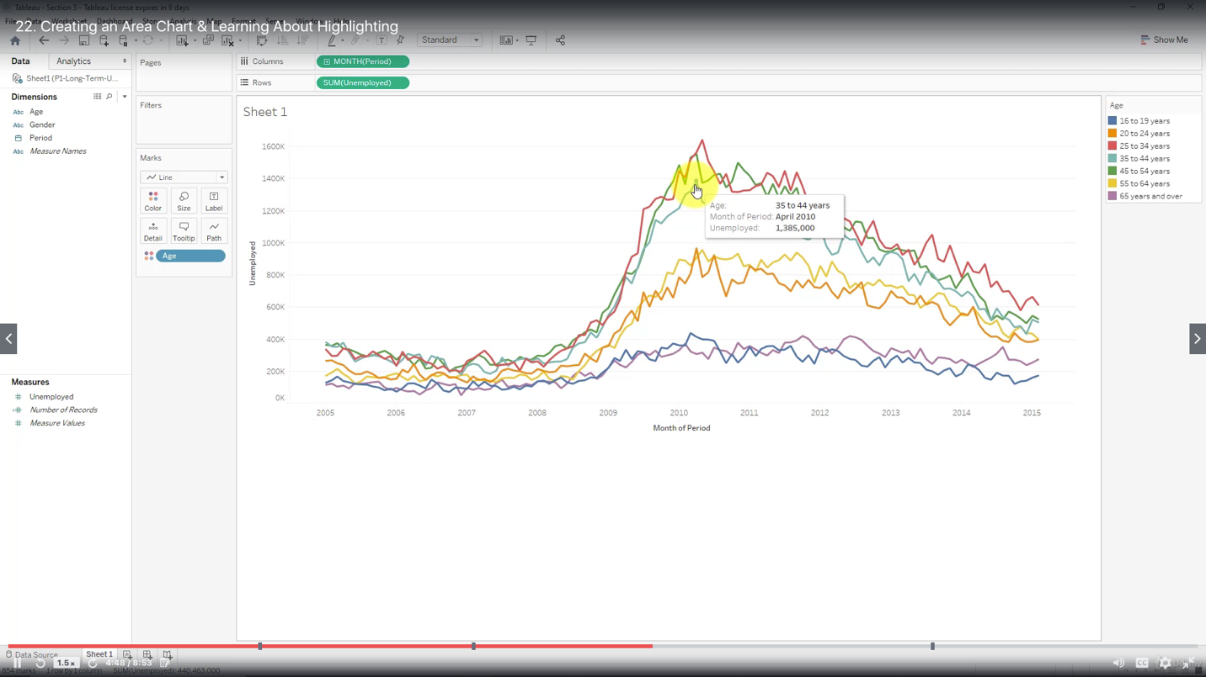

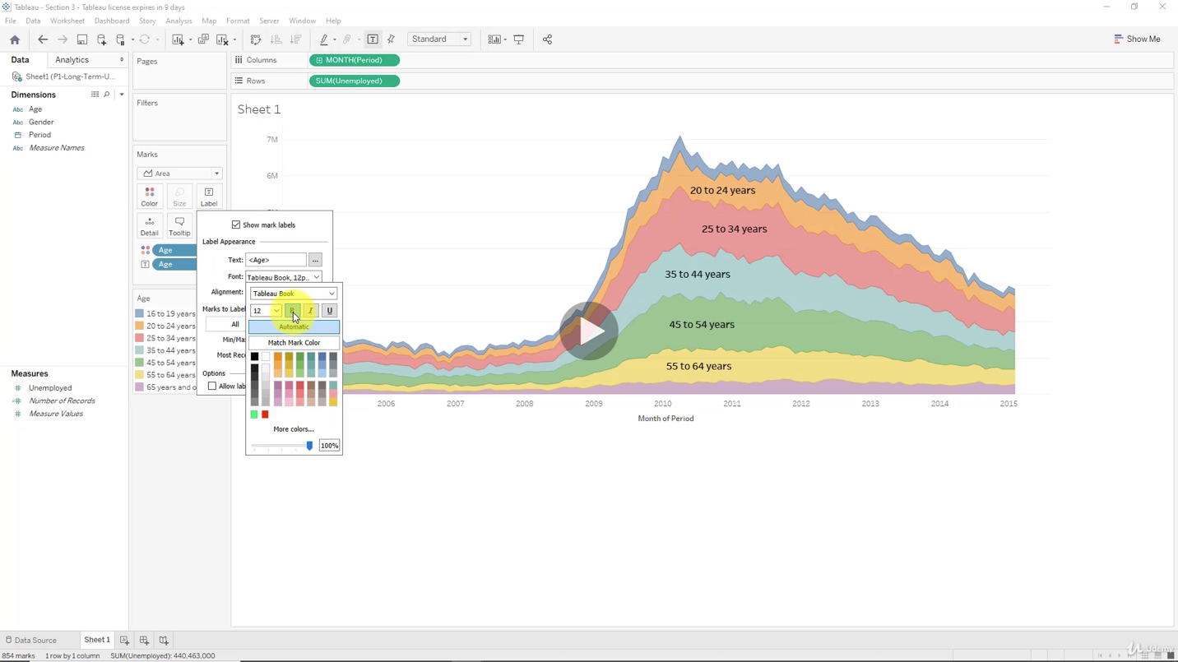

Filter & Quick Filter

Type of Quick Filter:

Single Value (List)

Multiple Value (List)

Wildcard Match

